Assignment 2 – Part A

Dr steve mckinlay

2231290

Andrew Graff

2024

Table of Contents

**Executive Summary2**

**Statement of Scope3**

Purpose of Application3

Main Business Requirements3

**Use Case Diagram4**

**Functional and Non-Functional Requirements5**

**Stakeholders and Interest6**

**ER Model7**

**Prototype Sketch of App8**

**References (nil used)10**

# Executive Summary

Talofa lava, in this report we have six different sections that will entail the designing of a new application. We have been hired as an Analyst for a smartphone development company and have created this report for an overview process of what and how we design this. The name of this application will be “PredatorFree 2024”.

# Statement of Scope

The main purpose of this application is enabling anyone in New Zealand to report any sightings of pests or predators using their smartphone.

This mobile application will help the New Zealand Government move towards reaching their goal of achieving a predator free New Zealand by 2050. The aim of this application will be providing useful data and information for the Department of Conversation to use in achieving the desired goal. Reporters, DOC and Government will benefit from using the application by alerting others of pests to help protect potential threats to wildlife, constituting a safer environment and a well track record of pests.

Main business requirements for the new system are the application to operate on a smartphone with capabilities of capturing sightings of pest with enabled GPS location, personal information input by the reporter and having these details accessible by DOC to review. Complete reports will be key in generating the data and frequent updating of the PredatorFree Database.

# Use Case – Diagram

*Actors: Reporters, Pest Control Officers and DoC Rangers*

* **Registering (**Registering your account, logging in using unique Reporter ID)
* **Submitting Pest Sightings** (Submit Pests Sightings – options for photo or no photo, apply mandatory information required)
* **Report Pest Sightings** (Generate fully completed reports for DOC)
* **Access PredatorStore Database** (Complied information of all collected data)

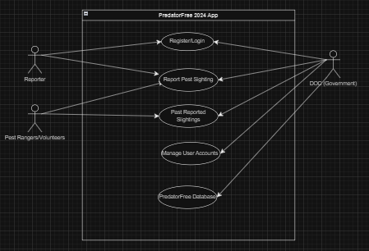

**Below is has a little more detail of the above Use Case Diagram**

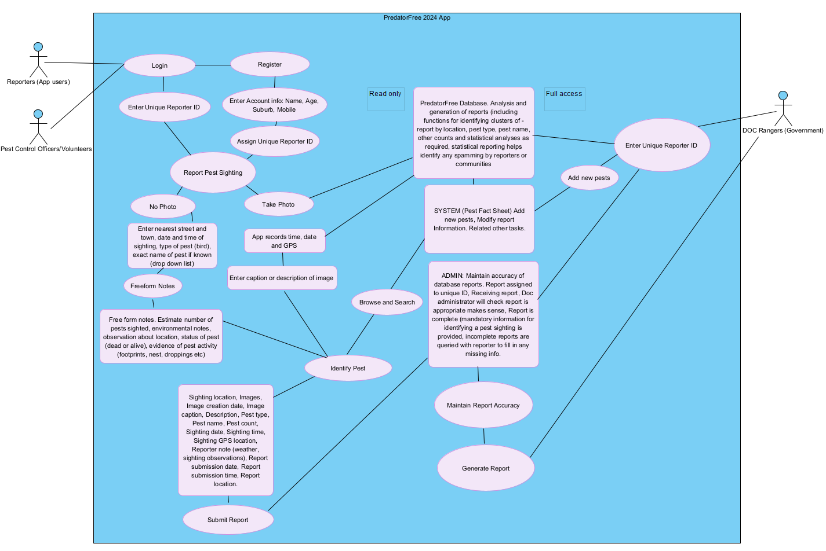

# Functional and Non-Functional Requirements

|  |  |
| --- | --- |
| **Functional** | **Non-Functional Requirements** |
| Login/Register (Logging in or creating an account) | **Application capability on all smartphone devices** |
| Enter Account Details | **GPS enabled connectivity to photo capture** |
| Enter Unique Reporter ID Number | **Encrypted data storage of personal information (passwords)** |
| Free form Notes | **Wildlife application friendly** |
| Report Pest sightings | **Readable code to ensure regular debugging upgrading if needed** |
| Submit Report | **Cloud storage backups of data** |
| Browse and Search | **Visual recording capabilities** |
| Identify Pests | **Recognition Option** |
| Take Multiple Photo | **Smartphone automatically records information** |
| Add New Pests | **Cloud based environment** |
| Enter caption or description image | **SQL Database** |
| Maintain Report Accuracy | **Authentication methods** |
| Generate Report |  |
| Pest Fact Sheets |  |

These are the functional requirements of the application as expressed In the Predator Free document. Reporter (user) functionality will only be able to access limited functions and DOC, Predator control officers (Pest Rangers) and DOC (Government) will have different functionality such as viewing submitted reports, Administering Pest Fact Sheets.

Database will analyse and generate reports. This will identify clusters of report by location, pest name and type, counts/statistical analyses that helps identify any spamming (Admin based).

Accuracy of the Database report is essential for clear structured data. Functional requirements include the assigning of unique reporter ID, checking submitted reports ensuring completion and follow-up if necessary (DOC/Govt).

Non-functional requirements lead more towards the system-based side of the application with processing speeds, the presentability, and how it flows in accordance with what is asked of a Predator Free app. An equally important aspect to ensure the app is appealing to use and download for users to remain engaged with software when out and about.

# Stakeholders and Interest

The stakeholders would be the New Zealand Department of Conservation (Government) with the interests of keeping New Zealand Pest Free by 2050. The NZ DoC would be main funders of this application software and will oversee all the goings in the development of the project.

Researchers would require the vital information to formulate plans for the Government and the resulted findings. An enabling way to see how to continue creating plans to move forward in achieving the desired goal.

Reporters providing valuable data to the DoC. These are by way of reporting such sightings of pests or any data leading to the presence as such. Taking photos, or freeform notes, documentation of reports, filling out mandatory information is of great interest. Reporters being the New Zealand public and potentially ratepayers are also invested in the project.



Pest Rangers (Control Officers)/Volunteers are the Pest management team proactively in the environment to deal with the pests for investigation and handling. Interests involve the protection of wildlife by actioning on the reports. This involves accessing the reported information by reporters and actioning the allocated tasks.

Scientists may have interest in the application to understand the study of wildlife birds, what locations they are spotted, findings of any trends of change of behaviour based on the analysis of the report.

Animal rights activists may also have an interest in the application as a measurement of what information is being recorded, stored to see what is happening with wildlife or how pests are being reported/handled by Pest Control Officers.

Private businesses/companies may have an interest in the application such as farmers/horticultural growers that own animals or land that are harmed by pests.

# Entity Relationship Diagram

Here we have an entity relationship diagram, with four classes; Reporter (Users of the Application), Pest Ranger (Control Officers), Pest Report (Submitted Pest Reports) and DOC (Government).

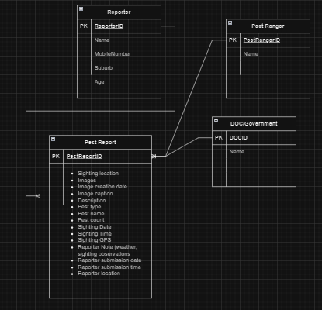

The Relationships are one to many for Reporters and Pest report as we can have one reporter with many pest reports. Pest Rangers also can report pests and see these files so an association is linked to the Pest Report. Lastly, the Pest Report is directly linked to DOC/Government as they have full administrative access indicating the relationships between all four classes. The attributes are the values within the classes. There are one to many relationships.

**Pest Report would be a bridge entity between Reporter, Pest Ranger and DOC/Government**

# Prototype sketches of the new app

1. **Login / Register**
2. **Report Pest Sighting**
3. **Name and Unique Reporter ID issued/Or input**
4. **Photo or No Photo – leads to issuing caption/description/add photos**
5. **Identify Pest (Pictures of Pests or unknown)**
6. **FreeForm Notes – enter any notes**
7. **Submit Report (send report)**
8. **Admin – Past Report/Manage Account/PredatorFree Database**
9. **Admin – PredatorFree Database**
10. **Admin – PredatorFree – list**
11. **Admin – Add new pest function**
12. **Admin – Edit/Remove Pests**
13. **Admin – Pest Fact Sheet (read only access for Reporters)**
14. **Admin – DOC mode**
15. **Admin – Pest Ranger mode**
16. **Admin – Contact details/Email**
17. **Predator Free – Search and Browse (function for all)**
18. **Predator Free – Track (footprints)**
19. **Admin – Predator Free (tasks completion)**
20. **Predator Free – Acknowledgement for report**

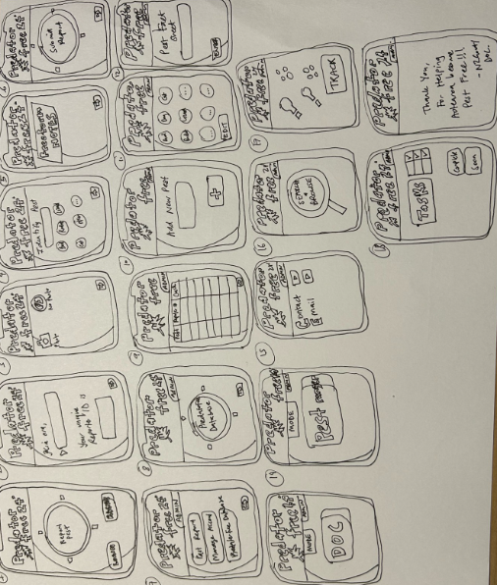**Prototype sketch:**

**(No references were used)**